**UNIVERSIDAD AUTONOMA DE COAHUILA**

**CENTRO DE IDIOMAS UNIDAD PIEDRAS NEGRAS**

**LINK IT 1B**

**LEVEL 2**

**2ND EXAM**

**STUDENT’S NAME: ____________________________________ DATE: ________________**

**TEACHER’S NAME: ____________________________________**

**PART I. VOCABULARY (15 points)**

Look at the pictures. Write the sports.

 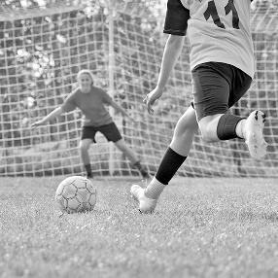

**1** play ____________ **2** play ____________

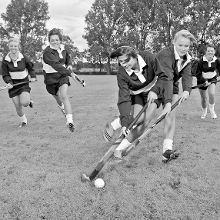 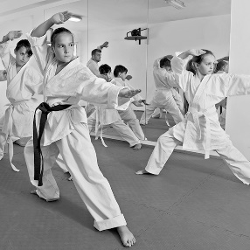

**3** play ____________ **4** do ____________

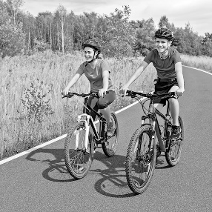 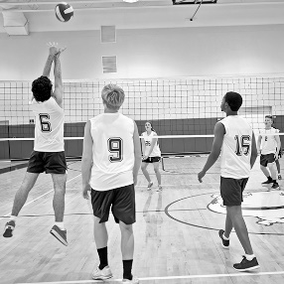

**5** go ____________ **6** play ____________

 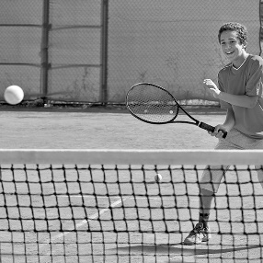

**7** do ____________ **8** play ____________

Complete the lists with the words in the box.

|  |
| --- |
| salmon corn soda cheese peaches ham |

**1** DRINKS: milk, orange juice, __________

**2** FISH: tuna, __________

**3** DAIRY PRODUCTS: milk, __________

**4** VEGETABLES: carrots, peas, __________

**5** FRUIT: grapes, pears, __________

**6** MEAT: chicken, __________

**Choose the correct alternatives.**

**1** **play tennis** / **play baseball**

**PART II. GRAMMAR (15 points)**

Complete the sentences with object pronouns.

**1** Mrs. Jones is our teacher. She teaches ____ French.

**2** This music is terrible. I hate ____!

**3** That’s my ice cream! Give it to ____!

**4** My grandma is awesome. I love ____.

**5** Your friends are cool. I like ____.

Choose the correct alternatives.

**1** Birds can / can’t play tennis.

**2** We can’t / can speak English. “Hello!”

**3** Fish can / can’t swim.

**4** Babies can’t / can write.

**5** Mice **can** / **can’t** talk.

Complete the sentences with affirmative (✓)   
or negative (🗶) imperatives. Use the words in   
the box.

|  |
| --- |
| go play watch look use listen |

**1** ________________ phones in class! (🗶)

**2** ________________ to this song! It’s great. (✓)

**3** ________________ basketball in the classroom! (🗶)

**4** ________________ that show! It’s fantastic. (✓)

**5** No! ________________ at my photos! They’re terrible! (🗶)

**PART III. LISTENING (5 points)**

T03 Listen to the radio interview. Choose the correct alternatives.

**1** The interviewer is talking to a **famous person** / **student**.

**2** Marcus **never** / **sometimes** walks to school.

**3** He usually has **pizza** / **sandwiches** for lunch.

**4** He visits his **cousins** / **friends** on the weekend.

**5** He rarely **reads** / **watches TV**.

**PART IV. READING (5 points) points)COMPREHENSION**

Read the blog. Then do the exercises.

**Food in Texas**

*How often do you eat in restaurants? What dishes do you love? Do you know how to cook them? This week’s food blog is by Clara West from Corpus Christi, Texas.*

Corpus Christi is a great place to try Texan food—especially fish dishes—because it’s next to the ocean. There are some great restaurants, but my favorite restaurant is my grandparents’ restaurant, The Catch. I often go there after school, and my grandpa teaches me how to cook regional dishes.

Tacos with meat are popular in Texas, but here in Corpus Christi we love fish tacos. Tourists love them, too. They’re white fish in corn tortillas with yogurt, vegetables, Mexican cheese, and special flavorings. Perfect! My favorite dish is Shrimp Picayune. It’s shrimp with lemon juice and brown sugar. It’s fantastic with rice and salad. I have it once a week.

Of course, Texans love meat. Chicken Fried Steak is a famous Texan dish. But it doesn’t have any chicken in it! It’s beef (red meat) fried in egg and flour. People usually eat it with potatoes and vegetables.

On the weekend, my friends and I often have lunch in town. We don’t usually sit in restaurants. We buy sandwiches, pizzas, or tacos. My favorite lunch is a hamburger and fries from a great restaurant called Lulu’s. We sometimes have a float. It’s soda with ice cream in it.

Sundays are great. My parents and I never get up early on Sundays. We sometimes walk to the Yellow Bird Restaurant for a late breakfast. They make a big English breakfast, and we love it! In summer, we have a barbecue by the ocean about once a month. Dad cooks and we sit by the ocean, eat awesome food, and chill out!

Read the text . Are the statements true (*T*), false (*F*), or not in the text (*N*)?

**1** Clara West writes a blog every day. ___

**2** You can see the ocean at Corpus Christi. ___

**3** Clara’s grandpa works in Corpus Christi but Clara never sees him. ___

**4** Corpus Christi is a very small town. ___

**5** Clara doesn’t like chicken fried steak. ___

**PART V. WRITING (10 points)**

Imagine you are Charlie. Use the checked (✓) information in the chart to write a paragraph about your abilities.

|  |  |  |  |  |  |
| --- | --- | --- | --- | --- | --- |
|  |  |  |  |  |  |
| **swim** |  | ✓ |  |  |  |
| **ski** |  |  |  |  | ✓ |
| **paint** | ✓ |  |  |  |  |
| **cook** |  |  |  | ✓ |  |
| **draw** |  |  | ✓ |  |  |

Hi, I’m Charlie. ____________________________

_________________________________________

_________________________________________

_________________________________________

_________________________________________

_________________________________________

_________________________________________

_________________________________________

_________________________________________

_________________________________________

_________________________________________